**Cloud & Security**

**Lab Assignment 2**

**Name :- Suraj Kumar**

**PNR:- 240840127041**

1. **Create a VPC in AWS with address as 172.20.0.0. Create a public subnet and a private subnet. Connect Internet Gateway to the public subnet. Create an EC2 instance connect it to the public subnet. Create another EC2 instance and connect it to private subnet. Display that you are able to connect using putty to the EC2 instance in the public subnet.**

**2. Copy the key of the second EC2 instance to the EC2 instance in the public subnet. Display that you are able to ssh to the EC2 instance in the private subnet from the EC2 instance in the public subnet.**

**Step :1 Create a VPC**

In the "Create VPC" wizard:

Name tag: "MyVPC"

IPv4 CIDR block: 172.20.0.0/16

Leave other options as default (IPv6, Tenancy).

Click Create VPC.

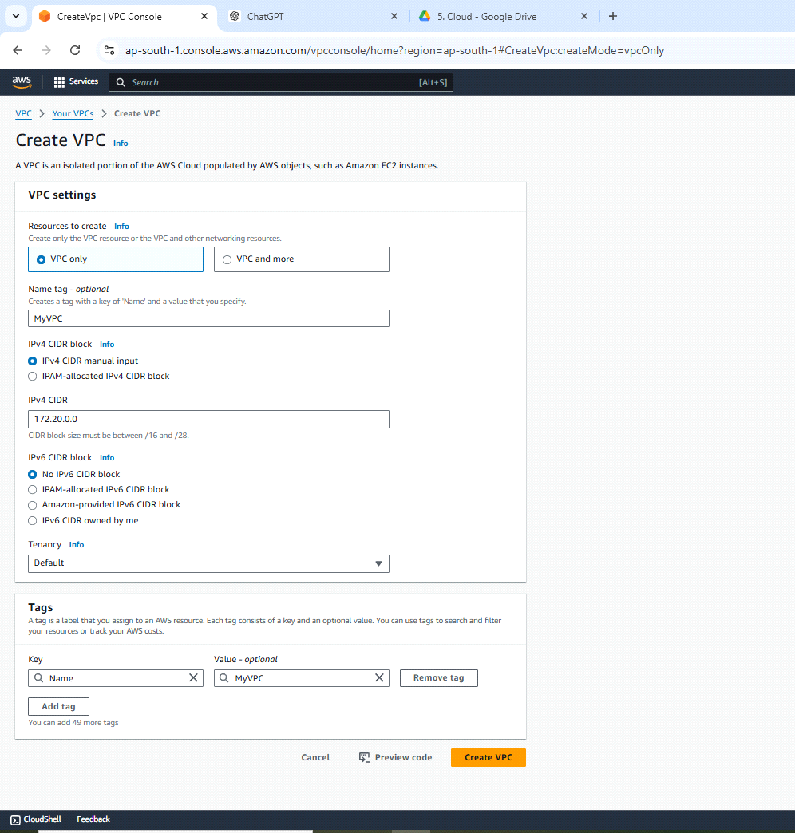

**Step 2: Create Public and Private Subnets**

After creating the VPC, go to the Subnets section.

Create the Public Subnet:

Click Create subnet.

Select the VPC created in Step 1.

Name tag: "PublicSubnet"

Availability Zone: Choose one (e.g., us-east-1a).

CIDR block: 172.20.1.0/24

Click Create subnet.  
  
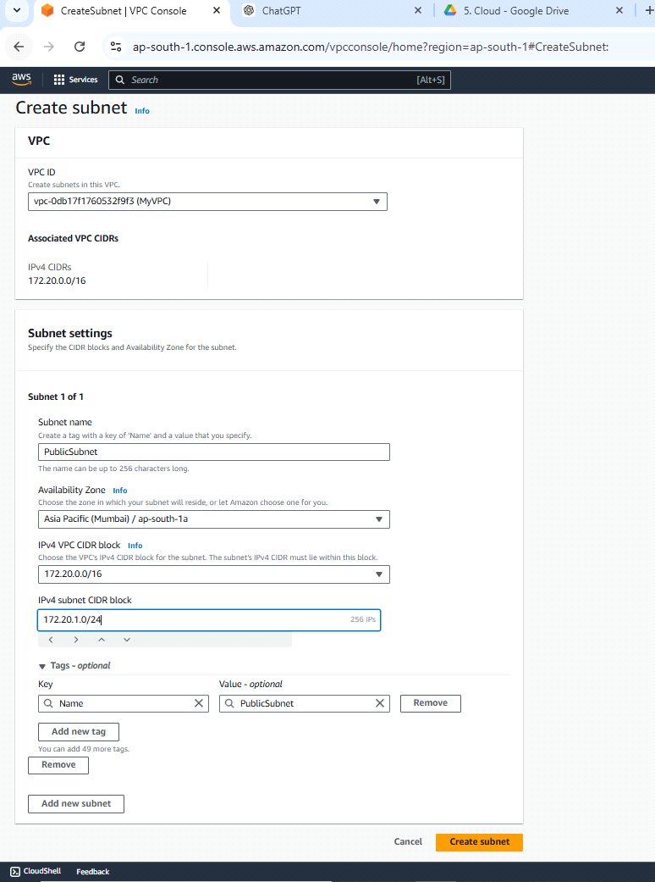  
  
3 **Create the Private Subnet:**

Click Create subnet again.

Select the same VPC.

Name tag: "PrivateSubnet"

Availability Zone: Choose the same or different (e.g., us-east-1b).CIDR block: 172.20.2.0/24Click Create subnet.  
  
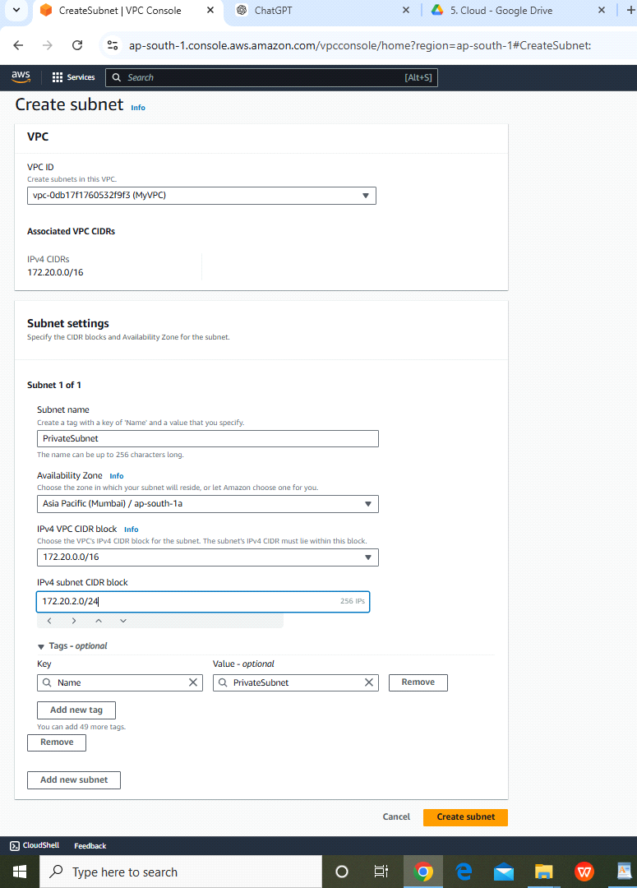

**Step 3: Create an Internet Gateway (IGW)**

Go to the Internet Gateways section in the VPC Dashboard.

Click Create internet gateway.

Name tag: "MyInternetGateway"

Click Create and then Attach to VPC.

Select the VPC ("MyVPC") and click Attach.

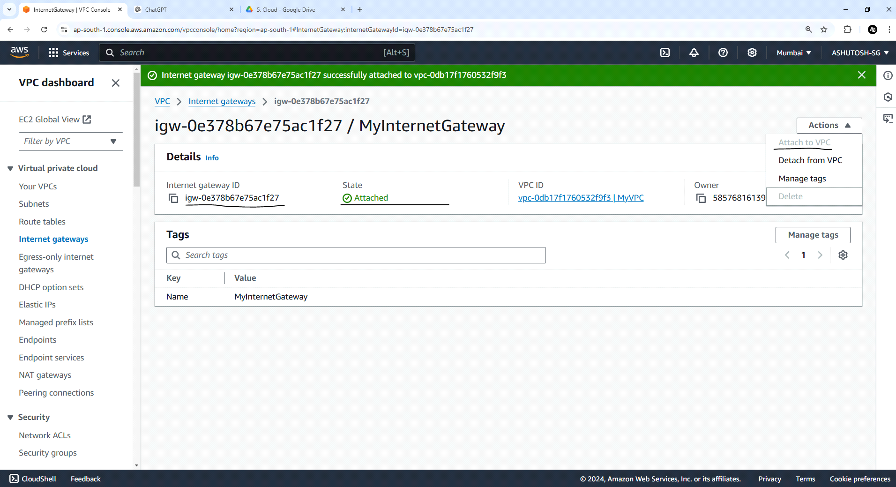

**Step 4: Create Route Tables**

*Create route tables to control traffic flow within your VPC.*

**1. Create Route Table for Public Subnet:**

* In the VPC dashboard, go to Route Tables.
* Click Create route table.
* Name tag: Enter a name (e.g., "Public-Route-Table").
* VPC: Select your VPC.
* Click Create.
* *Edit Routes:*
  + Select the newly created route table and go to the Routes tab.
  + Click Edit routes > Add route.
  + Destination: Enter 0.0.0.0/0 (for all traffic).
  + Target: Select your Internet Gateway.
  + Click Save routes.
* Associate Route Table with Public Subnet:
  + Go to the Subnet Associations tab.
  + Click Edit subnet associations.
  + Select your Public Subnet and click Save.

**2. Create Route Table for Private Subnet:**

* Click Create route table again.
* Name tag: Enter a name (e.g., "Private-Route-Table").
* VPC: Select your VPC.
* Click Create.
* Edit Routes and Associate Route Table with Public Subnet:
  + Private subnets typically don’t have direct internet access, so leave the default route.

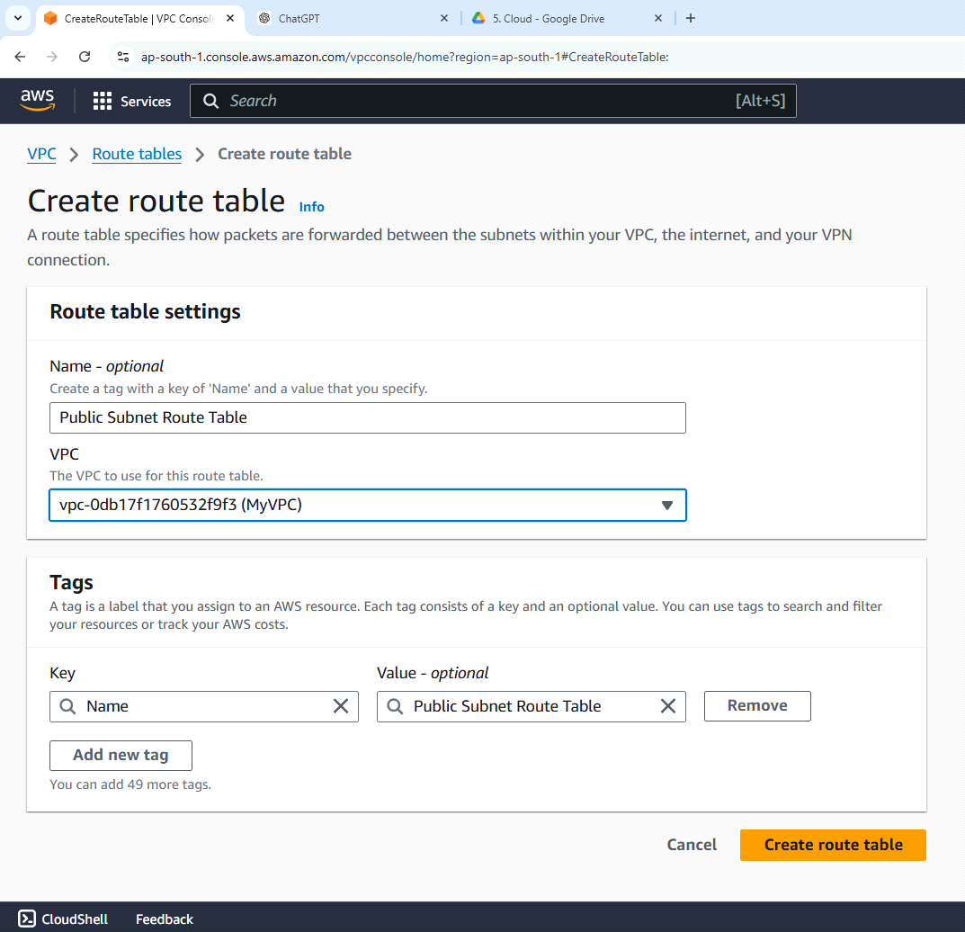

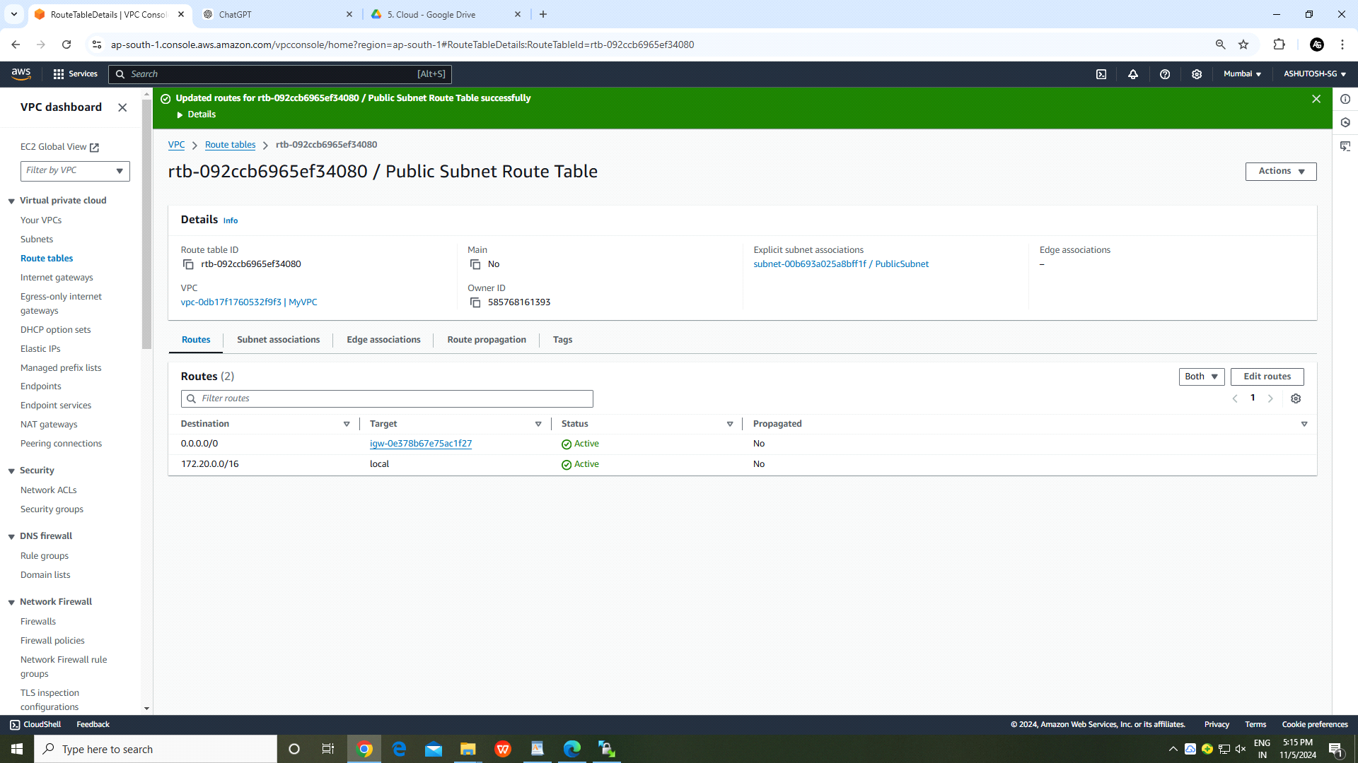

**Step 5: Launch EC2 Instance in the Public Subnet**

Go to the EC2 Dashboard and click Launch Instance.

Select an Amazon Machine Image (AMI) (e.g., Amazon Linux 2).

Choose an Instance Type (e.g., t2.micro).

In the Network section, select the VPC ("MyVPC") and Subnet ("PublicSubnet").

In the Configure Security Group section:

Create a new security group or select an existing one.

Add an inbound rule to allow SSH (port 22) from your IP address.

Key Pair: Create a new key pair **((.pem)**download and save it; you will need it for SSH).

Click Launch Instance.  
  
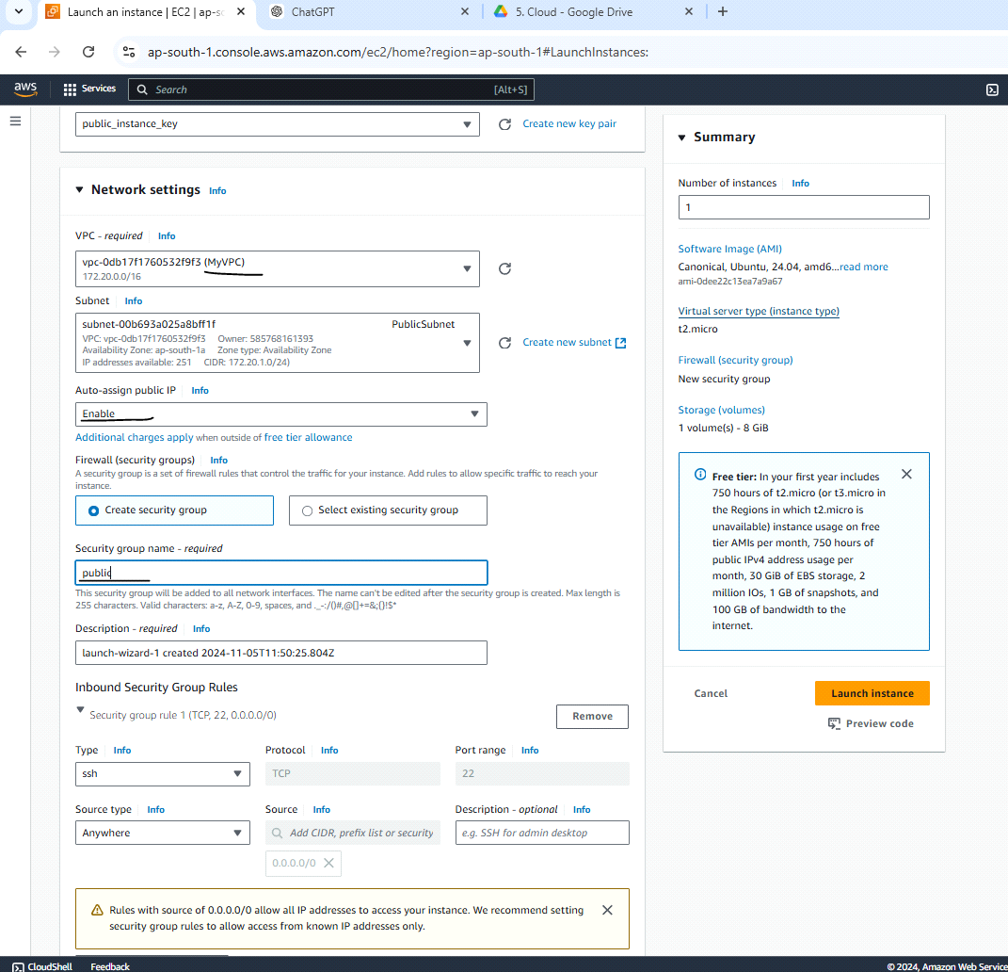

**Step 6: Launch EC2 Instance in the Private Subnet**

Follow the same steps as above to create another EC2 instance in the Private Subnet.

Only change is disable auto assign IP an chose private subnet  
  
EDIT NETWORK SETTINGS

In the Network section, select the VPC ("MyVPC") and Subnet ("PrivateSubnet").

Click Launch Instance.  
  
  
  
  
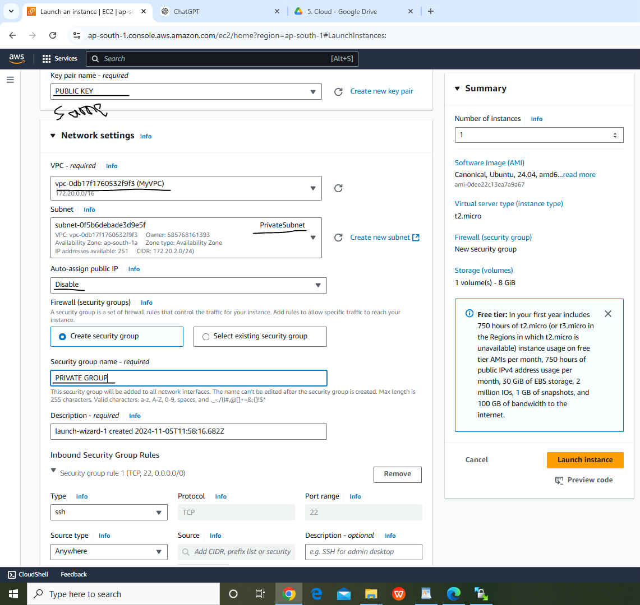

USE PUTTY GEN TO CONVERT .PEM to .PPK  
  
  
Step 7: Connect to the Public EC2 Instance via SSH (using Putty)

Open Putty (Windows) and enter the Public IP of the public EC2 instance.

Under Connection → SSH → Auth, browse to the private key file (in .pem format) for the public EC2 instance and select it.

Click Open to connect to the EC2 instance. You should be logged into the EC2 instance in the PublicSubnet.  
  
  
by **using winscp**copy pem file to local to ec2 instance

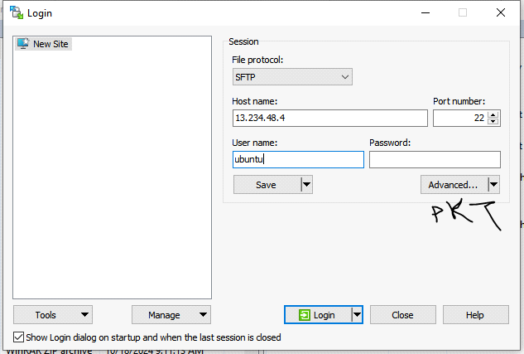

move pem file to the public instance BY DRAG AND DROP

Last Step:-  
  
ubuntu@ip-172-20-1-231:~$ ls

'PUBLIC KEY.pem'

ubuntu@ip-172-20-1-231:~$ chmod 400 PUBLIC\ KEY.pem

ubuntu@ip-172-20-1-231:~$ ssh -i "PUBLIC KEY.pem" 172.20.2.223

**Finally we are connected to private instance via public instance**

